THYRISTOR CONTROLLED POWER FOR INDUCTION MOTOR
ABSTRACT

The project is designed to control AC power to a load by using firing angle control of thyristor. Efficiency of such power control is very high compared to any other method.
The project uses zero crossing point of the waveform which is detected by a comparator whose output is then fed to the microcontroller. The microcontroller provides required delayed triggering control to a pair of SCRs through opto isolator interface. Finally the power is applied to the load through the SCRs in series. This project uses a microcontroller from PIC family which is interfaced through a push button switch for increasing or decreasing the AC power to the load. A lamp is used in place of an induction motor whose varying intensity demonstrates the varying power to the motor. The varying power results in variation in speed of the motor.
The project can be further enhanced by using direct 230 volt supply instead of 12 volt AC to the bridge rectifier for achieving higher voltage control for charging number of batteries in series.

BLOCK DIAGRAM
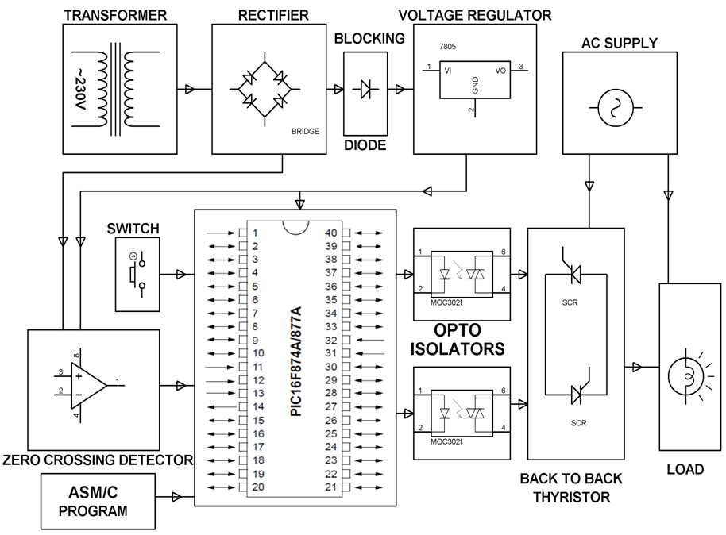

HARDWARE REQUIREMENTS:

PIC series Microcontroller, LM358, Opto isolators, SCRs, Push Button, Transformer, Diodes, Voltage Regulator, Resistors, Capacitors, Crystal, Lamp.

SOFTWARE REQUIREMENTS:

HI-TECH PICC Tool suite

Languages: Embedded C or Assembly

